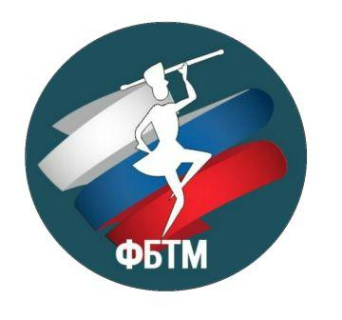

GRAND-PRIX MAJORETTE-SPORT
St. Petersburg /RUSSIA
28-29.09.2019

1. To apply for a visa at the Russian Consulate, you should make a list of participants

An example of a list:

№ | Name, Surname | date of birth | passport
1 | IVANOVA DANKA | 07.04.2001 | DA 234569

2. To send the list on mail Center "InterArt" mailto:p123@bk.ru

3. Find out in the Russian Consulate the list of documents required to obtain a visa.

4. Collect all the necessary documents and together with an invitation to get a visa to Russia.

5. We will write in the invitation that the Consulate will make for your group a humanitarian (free) visa, but the decision on such visa is made by the Consul of Russia in your country.

